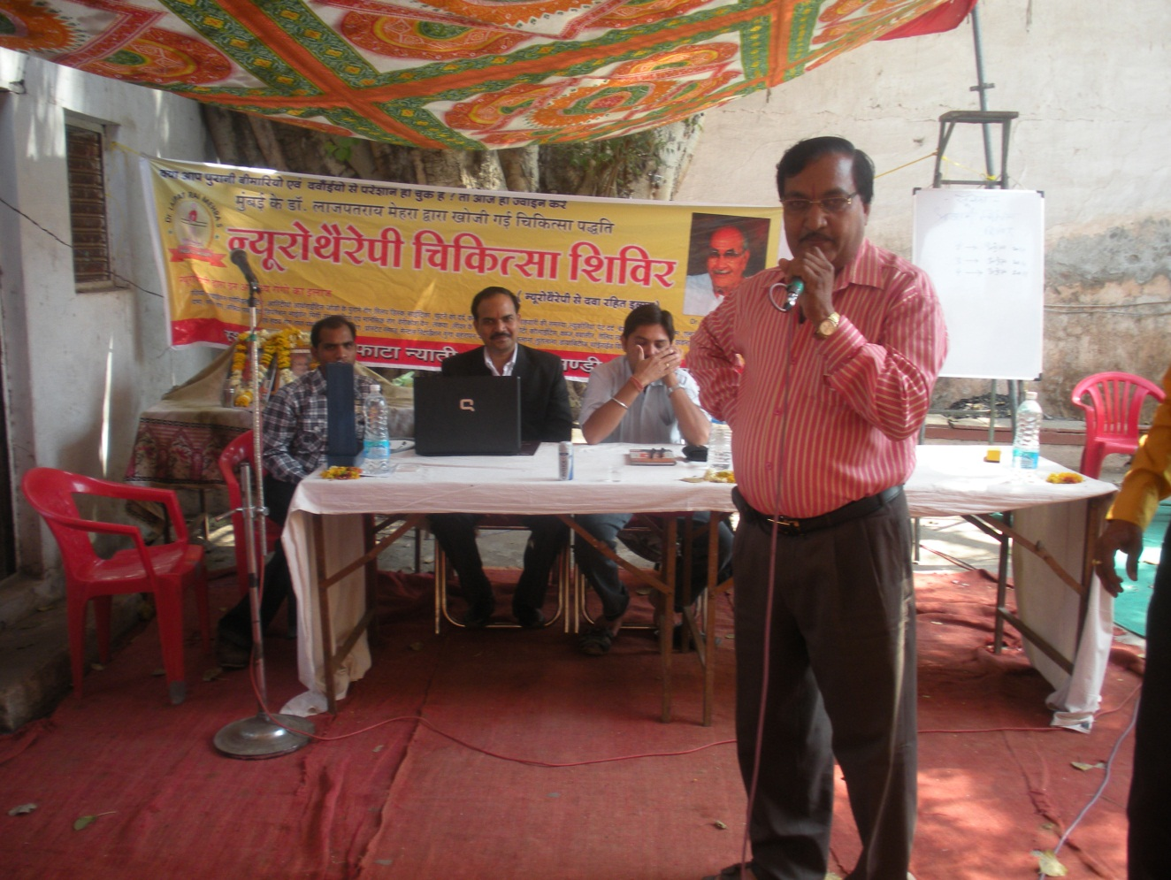

LMNT Camp at Dhamnod village, Dhar Dist. MP, 6.3.2011

